Field Course: Tropical Forests and Agroforests (FOR248)
2015

4-21 January 2023,
Luang Prabang, Laos

INFO HANDBOOK

GENERAL INFO:

This booklet has been prepared to provide general information about field course. Please keep this booklet along with you during the course. Any feedback is greatly appreciated.

WEBSITES:

UNIVERSITY OF HELSINKI:
https://www.helsinki.fi/en

SOUPHANOUVONG UNIVERSITY: http://www.su.edu.la/

VITRI:
https://www.helsinki.fi/en/researchgroups/viikki-tropical-resources-institute
https://www.facebook.com/UH.VITRI/?ref=bookmarks

Previous field courses:
- https://blogs.helsinki.fi/vitriblog/https-blogs-helsinki-fi-vitriblog-courses-events/laos-field-course-2019/
- https://www.youtube.com/channel/UCN5n_otiZQG79qEgS0L1eoQ/videos

Field Course Facebook:
https://www.facebook.com/groups/1515674882213134/about

Learning objectives
After participating in the course, students will be able to identify and describe central issues of tropical forest management and land use policies and apply the basic methodologies of ecological and socio-economic field research, as related to a specific country and location.

Contents of the course
Arranged as an international course with partner universities in tropical countries. The course includes pre-reading of literature, introductory lectures, and group work in the field. Covers the ecology, management, and conservation of natural and man-made production ecosystems (including agroforestry and estate crops); tree uses, including non-wood forest products; deforestation and forest rehabilitation; community forestry, socio-economic aspects, and forest and land-use policies.

Credits and workload
As you know, this is a 5 ECTs course which translates into many hours of work (at least 150 hours of work in 3 weeks. The course consists of lectures, field work, group report and closing seminar.

Additionally, the course has two evaluation activities; the first is a group work to be presented at the closing seminar on 20 January 2023, the second is a Group work video and Podcast on experiences in the field (details will be explained at the beginning of the course). A preliminary "group report" must be submitted before the closing seminar, and a final improved version can be submitted two weeks later in Finland.

To obtain the credits, students are expected to participate actively in all the course activities. Exceptions can be made on individual basis and will probably include a compensation activity. If the workload seems heavy, it is because international intensive courses are supposed to be like that.

General expectations
As students expect and deserve a good quality course, teachers and organisers also expect and deserve good quality students. The success of the course depends on all of us trying to do our best.

There are also general expectations in terms of international relations, good conduct, and local culture. If you do not show sufficient respect and understanding for local manners, expect the same in return. Many public buildings and religious places have limitations in terms of dress code and it is wise to take this into account; we all have to balance our needs for personal comfort and considerations of the social frame we will get involved into.

You are allowed to enjoy your free time as you please if it does not affect the general functioning of the course or the working groups.

Do not expect that the European standards of living will follow you all the way down to Southeast Asia. As a compensation, the food is good, beer is cheap, and people smile often. If you feel uncomfortable at any situation, please remember that you only have to endure it for a few hours or maybe a couple of days while millions call that uncomfortable situation "life" and the uncomfortable place "home".

You should not expect to pass this course just by being in the course; participants who are not up to the course standards will fail the course. This is of course undesirable.

Other considerations:
Some of you might consider these rules are unnecessary. This course is not a recreational activity; and you signed to participate on it, you share an equal responsibility with all the other participants. The VITRI's staff will be there to help you along the course.
Please remember that your participation during the discussions and the group work is important. Most of you have different backgrounds and the idea is to have different or even divergent perspectives about the topics we are studying. It will be also important for you to practice your language and discussion skills in an international environment. Do not feel afraid of expressing your ideas as they will only enrich the general discussion. For most people, these types of courses are a great experience, and they keep nice memories about the time they spend together long after the course finished. Be wise and try to make sure you are one of them. Keep an open mind and enjoy the ride!

PRACTICAL INSTRUCTIONS

LAO VISA
A single-entry tourist visa for Laos. Please notice that to apply for Lao tourist visa on arrival, you will require at least 40 USD in cash! No credit cards and no Euro banknotes are accepted. All EU and some other Nationals are eligible for 30 days Lao visa on arrival (http://www.retire-asia.com/lao-visa-on-arrival-30-days.shtml).

MONEY
In general, all your immediate costs related to the course are paid by the organisers, including local travel, accommodation and meals during scheduled work. You can check in at the hotel on 4th January before the course and leave on 21st of January after the course. You will need money for all unofficial meals and your own free program (e.g. in the evenings).

For your own personal expenses during the whole journey, you should carry at least 400 USD/EUR in cash, or a credit card. Credit cards are accepted in some places in Luang Prabang town, and USD/Euro/THB notes can be easily changed to Lao currency (Kips) at any exchange place. International credit cards/visa electron can be used at any ATMs in Laos.

CLOTHING AND OTHER EQUIPMENT
For lectures in campus all should wear collar shirt/T-shirt, since collarless and especially sleeveless shirts are considered inappropriate during official hours. Shorts and sandals/flip-flops are not used during official hours. For women, skirts are OK during official hours. A hat or cap is essential for everybody. For field work and excursions, long-sleeved shirts and long trousers/slacks are recommended. Please carry enough warm clothes, as January is the coldest month in Laos and no heating system in the room. Take only light footwear (safari shoes/boots or jogging shoes) for campus and field, plus sandals or thongs for evenings and bathrooms.
It is essential that you possess a study field-notebook, and do not write any notes on loose paper sheets. Several laptop computers for group work are needed; if you could bring one, please inform coordinator in advance.
It would be also recommended that you also insure your personal belongings (especially if you are carrying a laptop computer or an expensive camera.

RUCKSACKS INSTEAD OF SUITCASES
Pack your belongings in a rucksack, or soft bags, instead of a suitcase. In addition, you need a small strap bag (for your papers, camera etc.), during field work and excursions.

Valuables (passport, money) should be kept in a leather bag around your neck or inside your trousers, never in a back pocket. Useful small items: small flashlight, pocket knife for peeling fruits (but never in your hand baggage during flights!), sunglasses, sun lotion, antiseptic liquid soap, 50-100 carbon pills for stomach trouble (use stronger stomach trouble pills only for real emergencies, such as when in the bus), aspirin, band-aid Most Nordic cellular phone networks (such as Elisa and DNA) also function in Laos.

MEDICAL CARE
Everyone must carry Travel insurance documents. For vaccinations, consult your doctor.

FIRST AID TO LAO CUSTOMS
Hand-shaking is common in Laos. Remove your shoes while entering someone’s home, and temples (dress code is also important in temples or official buildings); when sitting or squatting, never direct your feet towards people or Buddha images. Do not touch other persons’ heads or walk publicly hand-in-hand or show any other intimate feelings. Try to follow the local custom (even when you are tired or in trouble). Show respect to towards religious objects and national heroes. Important: Laos is a communist country, so avoid talking about Lao politics while you are in Laos.

In restaurants, you could ask for written bills, however, don’t ask for separate bill while you are eating as a group. Learn the Lao names of your favorite foods and follow the custom of ordering, especially for an evening meal (Some useful Lao phrases https://www.laos-guide-999.com/learn-lao.html). Even though Laos is not a dangerous country, do not walk alone at night in Luang Prabang town or Nambak district.

ADDITIONAL REMARKS
This is a professional course, and you should be prepared for studying and field work while also relaxing and learning the local culture. Be prepared for a cultural shock, travel and accommodation in discomforts, and eating food which you cannot always choose yourself. Try to be cooperative and help your fellow participants when problems arise (they will, sooner or later). At some stage you will be very tired of field work, of continuously “keeping the face”, and of eating rice three times a day! Especially in the field, accommodation could consist of bedrooms shared by 3 persons; bathrooms sometimes consist of a jar filled with water and a squatting toilet (when using such a bathroom, you preferably should be dressed in a sarong and, at night, equipped with a torchlight).
In advance, try to read books on Lao culture (e.g. Lonely Planet travel guides).

Learning the essentials of Lao behaviour and language (greetings, numerals, names of basic foods) is useful to communicate in shops and tuktuk (local taxi) and on the street.

Course Students Information:
No | Institution | Name | Country
1 | University of Helsinki | Viivi Lindholm | Finland
2 | University of Helsinki | Viivika Haltia | Finland
3 | University of Helsinki | Emmi Kaislasalmi | Finland
4 | University of Helsinki | Katri Salo | Finland
5 | University of Helsinki | Marketta Juppi | Finland
6 | University of Helsinki | Sylvain Stübi | Switzerland
7 | University of Helsinki | Johanness Bin Jamaludin | Singapore
8 | University of Helsinki | Karuna Budhathoki | Nepal
9 | Kasetsart University (KU) | Thanyaporn Bangbai | Thailand
10 | Kasetsart University (KU) | Voratatta Sutthipak | Thailand
11 | Souphanouvong University (SU) | Bounxian Phetlumphun | Laos
12 | Souphanouvong University (SU) | Souksamone Phangthavong | Laos
13 | Chiang Mai University (CMU) | Worayut Takaew | Thailand
14 | Chiang Mai University (CMU) | Jarik Krobtong | Thailand
15 | Savannakhet University (SKU) | Nongkhan Borlivanh | Laos
16 | Savannakhet University (SKU) | Phoutalavanh Konkheuangkham | Laos

Course Teachers:
Edward Webb, Professor, VITRI, UH
Yirdaw Eshetu, University Lecturer, VITRI, UH
Markku Kanninen, Professor Emeritus, VITRI, UH
Dipjoy Chakma, Researcher, VITRI, UH

Field work group
Group 1 (Tree Inventory)  Supervisor – Edward Webb  Johanness Bin Jamaludin (UH)  Viivi Lindholm (UH)  Souksamone Phangthavong (SU)  Voratatta Sutthipak (KU) | Group 2 (Biodiversity)  Supervisor – Eshetu Yirdaw  Emmi Kaislasalmi (UH)  Viivika Haltia (UH)  Nongkhan Borlivanh (SKU)  Worayut Takaew (CMU)
Group 3 (Household survey)  Supervisor – Markku Kanninen  Karuna Budhathoki (UH)  Marketta Juppi (UH)  Jarik Krobtong (CMU)  Phoutalavanh Konkheuangkham (SKU) | Group 4 (Value Chain)  Supervisor – Dipjoy Chakma  Katri Salo (UH)  Sylvain Stübi (UH)  Bounxian Phetlumphun (SU)  Thanyaporn Bangbai (KU)

Course Programme 4 - 21 January 2023
Wednesday 4 January 2023
Theme: | Arrival to the accommodation
Location: | Town Centre, Luang Prabang
From 12pm | Check in to the “Hotel” TBC

Thursday 5 January 2023
Theme: | Course opening
Location: | FAF, Souphanouvong University (SU)
8:30-9:00 | Course opening; course logistics
9.00-11.00 | Forest restoration techniques  and cost/benefits (Lecture by Stephen Elliott and Prasit  Wangpakapattanawong, Chiang Mai University)
11.00-12.00 | Baci Ceremony
12.00 - 13.00 | Lunch
13.00 | Leave for Nambak District
17.00 | Check in Say Nambak hotel in Nambak District

Friday 6 January 2023
Theme: | Field work practice
Location: | Nambak District
08:30-12:00 | Plot measurement/FGDs/HHs interview practice
12:00 | Lunch
13:00 – 16.00 | plot measurement/FGDs/HHs interview practice
16:15 | Return to the guest house
17.00-18.00 | Group meeting

Saturday 7 January 2023
Theme: | Understanding the land use
Location: | Nambak District
08:30-12:00 | Understanding the land use
12:00 | Lunch
13:00 – 16.00 | Understanding the land use
16:15 | Return to the guest house
17.00-18.00 | Group meeting

Sunday-Sunday 8-15 January 2023
Theme: | Field work
Location: | Nambak district
8.00 | Departure for the case study villages
09:00-12:00 | Field work
12.00-13:00 | Lunch
13:00-16:00 | Field work
16:15 | Return to the guest house

Monday 16 January 2023
Theme: | Data analysis
Location: | Say Nambak Hotel, Nambak district
08:30-12:00  12.00-13.00 | Data analysis  Lunch
13:00-16:30 | Data analysis

Tuesday 17 January 2023
Theme: | Return to Luang Prabang city
Location: | Nambak district
08:00-12:00  12.00-13.00 | Trip to Luang Prabang  Lunch
18:00 | Check in “Hotel in Luang Prabang city” TBC

Wed-Thursday 18 - 19 January 2023
Theme: | Data analysis and PPT preparation
Location: | FAF, SU, Luang Prabang
08:30-12:00 | Group work
12.00-13.00 | Lunch
13.00-16.00 | Group work

Friday 20 January 2023
Theme: | Group work presentation and closing ceremony
Location: | FAF, SU, Luang Prabang
8:30-12.00 | Session 1
12:00-13:00 | Lunch
13.00-16.30 | Session 2
16.30-21.00 | Closing ceremony and Dinner

Saturday 21 January 2023
Theme: | Departure from Luang Prabang
Location: | Town Centre, Luang Prabang
By 12pm | Check out from “Hotel” TBC

Field course location:
Luang Prabang, Laos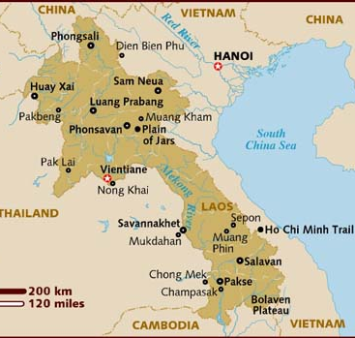

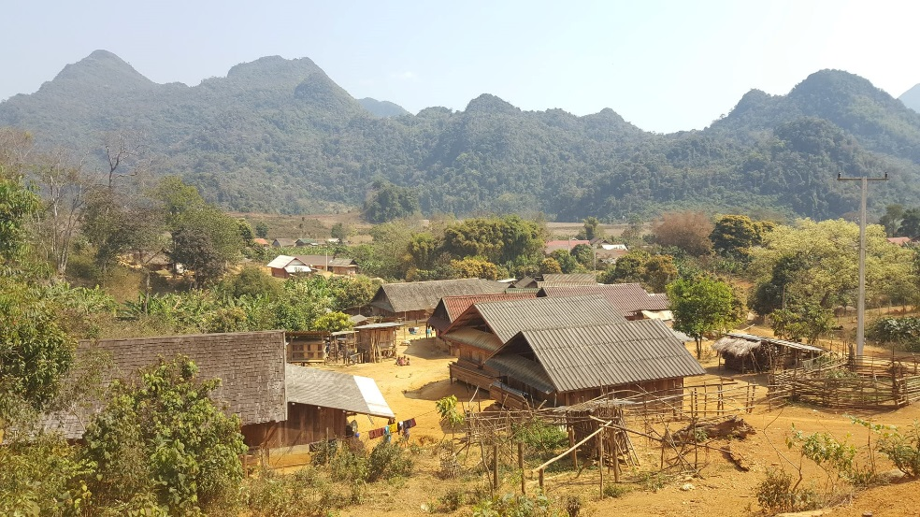
Pic: One of the field courses sites - Vieng Hinh Soung Village, Nambak District

Contact:
- Edward Webb, Email: edward.webb@helsinki.fi

- Dipjoy Chakma, Email: dipjoy.chakma@helsinki.fi

- Vongpasith Chanthakhoun, Email: vongpasith@yahoo.com

- Bounxian Phetlumphun, Email: fafxianfor@gmail.com

